Course: Data Science Roll No: TYCS-12

Aim: Practical on Analysis of Variance.

__________________________________________________________________________________

Output 1

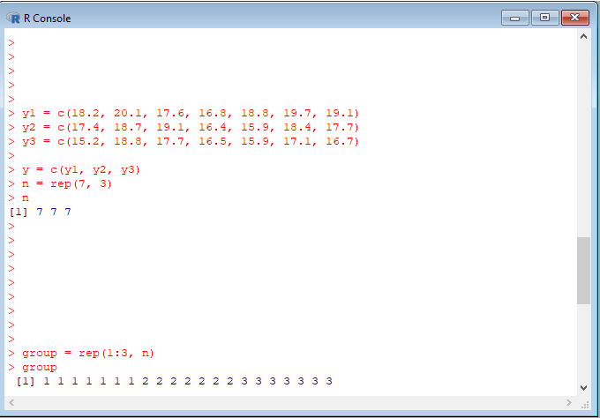

Output 2

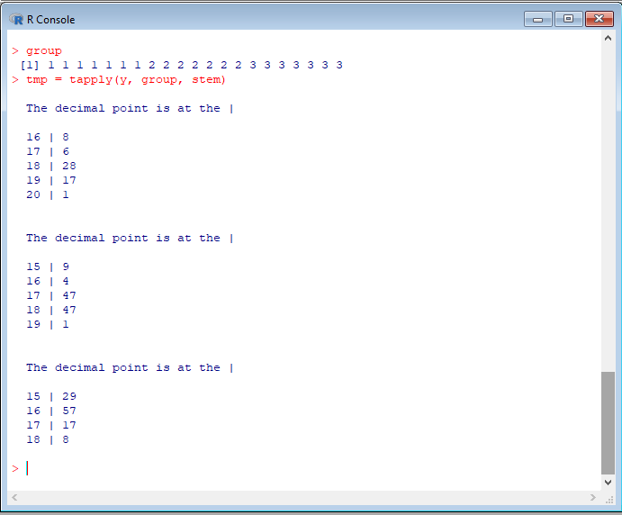

Output 3:

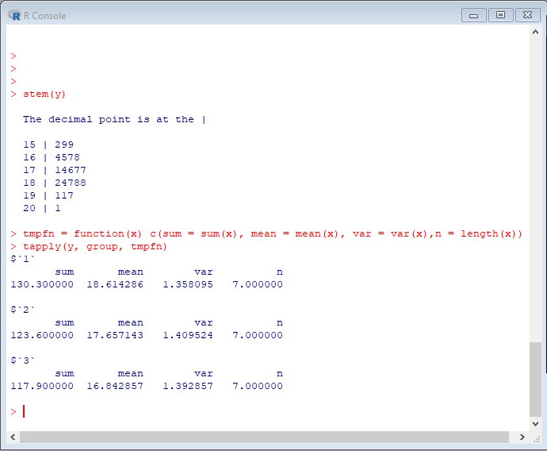

Output 4

